 | CHEMICAL EQUILIBRIUM
 | Chemical Reaction Systems
• | A reaction system refers to reactants and products ONLY in our discussion
• | Chemical reactions systems are divided into two systems, namely:
1. Open system
2. Closed system
 | Open System
• | An open system is a system which shares mass with the surroundings
• | This means some of the products may escape the reaction vessel as a result of that the total mass of the system will decrease.  This happens when one of the product is a gas and is not stored
• | However, the mass lost by the system will be gained by surroundings.  Hence, the law of conservation of mass is obeyed.
• | Also, some reactants may come from surroundings to the system
• | Effectively the mass of the system would increase, and then the mass of surrounding would decrease.  This is usually possible to reactants that may react with atmosphere i.e. oxygen and moisture
 | Closed System
• | In contrast to that, a closed system is a reaction system that doesn’t share mass with surroundings
• | This means neither reactants nor products may join or leave the system.
 | Chemical equilibrium / Dynamic Equilibrium
• | Chemical equilibrium is used to describe the reactions that do not go to completion.
• | However, they reach a stage with which the concentration of both reactants and products remain constant.
• | Therefore, these reactions are also termed reversible i.e. reactants are converted to products; also products decompose back to reactants
• | Chemical equilibrium is defined as the state of dynamic equilibrium where the rate of forward reaction is equal to the rate of reverse.

 | A reaction that has reached equilibrium maybe written as follows:
 | N_{2(g)} + 3H_{2(g)} ⇌ 2NH_{3(g)}
 | Where; a double arrow illustrates that both forward and reverse reactions are taking place.
 | Graphically equilibrium is shown as follows
 | Concentration(mol.dm⁻³) | Equilibrium state
Reaction progress / time (s)
Time
Rate of reaction
• | Industrially a reaction at equilibrium could result in a loss of profit, since there won’t be change in the amount of products.
• | However, the aim of industrial Chemistry is to increase productivity at minimal cost both financially and time
• | Then French Chemist Henry Louis Le Chatelier discovered that if some reaction conditions are changed, then the reaction could respond in a manner that opposes the change.
• | Le Chatelier’s principle states when the reaction in a closed system is disturbed, the system will re-instate a new equilibrium by favouring the reaction that will opposes the disturbance.
 | Factors Affection Equilibrium Position
 | There are three factors that affect the Equilibrium position, namely:
 | 1. Concentration
 | 2. Pressure
 | 3. Temperature
 | Concentration (Solutions)
• | Concentration is defined as the amount of particles per unit volume. It only applies to solutions.
• | Given the following hypothetical reaction equation we shall try to apply Le Chatelier’s principle.
 | A + B ⇌ C + D
• | From the above reaction the concentration of any of the reactants/products (A/B/C/D) of a reaction system could be altered, thus forcing shifting of equilibrium position. If any of the reactants/products is increased that will force the reaction at equilibrium to shift away from the increased reactants/products in order to decrease it. Furthermore, if any of the reaction reactants/products is decreased, then that will force the reaction at equilibrium to shift towards the decreased reactants/products in order to increase it.

 | Now, it is decided that [A] is added as stress to the system.
 | • | The increase in [A] will increase effective collision between [A] and [B]; thus that will force the reaction at equilibrium to produce more [C] and [D]. Therefore, we could say after the addition of [A] would force the reaction to shift towards [C] and [D] or addition of [A] would force the reaction to favour formation of [C] and [D] to re-establish equilibrium.
 | • | Any other change could be done on the reaction at equilibrium then the reaction will act against the change in order to minimize it.
 | • | Graphically the above scenario is shown as follows.
 | Graph : Shows the effect of increase in reactants of the above reaction
• | Since the pressure is inversely proportional to the volume from Boyle’s law, the change in pressure also affects volume.
• | If the pressure of the system is changed (by changing volume or amount of gas), the sum of stoichiometric coefficients of both reactants and products will decide the direction of equilibrium shifting.
• | An increase in pressure forces the reaction at equilibrium to shift towards the side with least moles.
• | A decrease in pressure forces the reaction at equilibrium to shift towards the side with most moles.
 | EXAMPLE
• | Given the Haber process then Le Chatelier’s principle will be in action.
 |  |  |  | N_{2(g)} + 3H_{2(g)} ⇌ | 2NH_{3(g)}
• | Mole count |  |  | 1 + 3  4  Reactants | 2  2  Products
• | From the above equation it is evident that products have least moles, whereas reactants have most moles.
• | Then, if in this reaction the pressure is increased, the concentration of all gases will increase, the side with the higher mole is initially favoured, and hence the equilibrium will shift towards (favours) the side with least moles (products).
• | Also if the pressure is decreased, then the reaction will shift towards (favours) most moles (reactants).
 | Graphically the above scenario is shown as follows:
 | Graph : Showing the effect of increase in pressure in Haber Process
 |  |  | Graph : Showing the effect of decrease in pressure in Haber Process
 | Temperature
 | When considering the change in temperature, firstly the type of reaction must be identified, whether it is endothermic or exothermic.
 | This is because the heat is absorbed in an endothermic reaction, then released in an exothermic reaction
• | When considering the change in temperature, firstly the type of reaction must be identified, whether it is endothermic or exothermic.
•
 | Given the following hypothetical reaction equation
 | A + B ⇌ C, ∆H < 0
• | What would happen in this reaction if temperature is decreased?
• | Since the reaction has an enthalpy less than zero that means the forward reaction is exothermic.
• | Hence, by decreasing temperature of an exothermic reaction that will force the reaction at equilibrium to shift towards (favours) products (C), then it will re-establish equilibrium.
• | Also, if temperature could be increased the reaction at equilibrium will shift towards (favours) reactants (A and B).
 | Graphically the above could be shown as follows.
 | Graph : Shows the effect of increase in temperature in an exothermic reaction
Time
Concentration (mol.dm⁻¹)
Time
Rate of reaction

 | Equilibrium Constant (K_{c})
• | This is a constant only at equilibrium; it is given by the ratio of product concentration to reactants concentration. Both reactants and products must be raised to their stoichiometric coefficients
 | e.g. aA + bB ⇌ cC + dD
 | $$K_{c}=\frac{{[C]}^{C}{*[D]}^{d}}{{[A]}^{a}*{[B]}^{b}}$$
• | K_{c} units are not considered at this level. Also K_{c} can ONLY be changed by change in temperature, other conditions which affect equilibrium position do not affect K_{c} value.
• | Also K_{c} value has physical interpretation as far the amounts of reaction reagents are concerned.
 | 1. | If K_{c} value is greater than 1 that means in the reaction mixture there are more products than reactants, thus a forward reaction is favoured than reverse.
 | 2. | If the K_{c} value is equal to 1, then that means the amounts of products are equal to the amounts of reactants.
 | 3. | If the K_{c} value is less than 1, then that means there are more reactants than products thus a reverse reaction is favoured.
 | 4. | K_{c} value increases when the temperature is increased for endothermic reactions
 | 5 | K_{c} value increases when the temperature is lowered for exothermic reaction
 | In equilibrium constant calculations the following steps must be covered
 | 1. | Write a balanced equation and then draw columns which must be equal to the number of reaction components + one column
 | 2. | On + one column write the following: Ratio (mole), initial (mole), change (used and produced) (mole), equilibrium (mole) and Concentration (mol.dm⁻³)
 | 3. | Fill in the ratios of the reaction components
 | 4. | Fill in the information from the data given on the question statement (Quantities used must be the same as those on + one column)
 | 5. | Use the substance given equilibrium amount to calculate unknowns
 | 6. | Equilibrium moles will be equal to the sum of initial mole and change mole
 | 7. | Then divide equilibrium moles with volume in dm³ to get concentration
 | 8. | Then substitute to the expression.  Note: pure liquids and solids are not included in k_{c} calculations
 | Example 1:
• | A mixture of 0.25 mole of NO and 0.10 mole of Br₂ is put into a 250 ml sealed container at 400K. Then the balanced equation is for the reaction is as follows:
 | 2NO + Br₂ ⇌ 2NOBr
 | At equilibrium the reaction mixture had 0.05 mol of NOBr
 | Calculate the equilibrium constant at that temperature.
 | Solution 1
 |  |  | 2NO_{(g)} + | Br_{2(g)} ⇌ | 2NOBr_{(g)}
 |  |  | 2 | 1 | 2
Initial (mole) |  |  | 0.25 | 0.10 | 0.00
Change (mole) |  |  | 0.05 | 0.025 | 0.05
Equilibrium (mole) |  |  | 0.20 | 0.075 | 0.05
C = n/v (mol.dm⁻³) |  |  | 0.80 | 0.30 | 0.20
 | $$K_{c}=\frac{{[NOBr]}^{2}}{{[NO]}^{2}[{{Br}_{2}]}^{1}}$$
 | $$K_{c}=\frac{({0.20)}^{2}}{{(0.80)}^{2}*({0.30)}^{1}}$$
 | $$K_{c}=0.208$$
 | Example 2 :
• | A certain amount of nitrogen dioxide gas (NO₂) is sealed in a gas syringe at 25 °C. When equilibrium is reached, the volume occupied by the reaction mixture in the gas syringe is 80 cm³. The balanced chemical equation for the reaction taking place is:
 | 2NO₂(g) ⇌ N₂O₄(g) ΔH < 0
 | At equilibrium the concentration of the NO_{2(g)} is 0,2 mol·dm⁻³. The equilibrium constant for the reaction is 171 at 25 °C.
 | Calculate the initial number of moles of NO_{2(g)} placed in the gas syringe.
 | Solution 2
 | Let initial number of moles of NO₂be x
 | 2NO_{2(g)} | ⇌ N₂O_{4(g)}
 | 2 | 1
Initial (mol) | X | 0.00
Change (used/ formed) (mol) | (x – 0.016) | (x-0.016)/2
Equilibrium (mol) | 0.016 | (x-0.016)/2
$c=\frac{n}{v}$ (mol.dm⁻³), v= 0.08 dm³ | 0.2 | (x – 0.016)/0.16

 | $$K_{c}=\frac{[{N_{2}O_{4}]}^{1}}{[{{NO}_{2}]}^{2}}$$
 | $$171=\frac{\{\frac{\left(x-0.016\right)}{0.16}\}}{{(0.2)}^{2}}$$
 | $x=$1.11 mol
 | Example 3
• | The reaction, represented by the equation shown below, reaches equilibrium at a certain temperature in a 2 dm³ closed container. On analysis of the equilibrium mixture, it is found that 0, 60 mole of SO₂(g), 0,50 mole of O₂(g) and 0,40 mole of SO₃(g) are present in the container.
 | 2SO₂(g) + O₂(g) ⇌ 2SO₃(g), ΔH < 0
 | The temperature is NOW increased and the reaction is allowed to reach equilibrium for the second time at the new temperature. On analysis of this new equilibrium mixture, it is found that 0,20 mole of SO₃(g) is present in the container.
 | Calculate the equilibrium constant for this reaction at the new temperature.
 | Solution 3
 | 2SO₂(g) | + O₂(g) | ⇌ 2SO₃(g)
Ratio (mol) | 2 | 1 | 2
Initial (mol) | 0.60 | 0.50 | 0.40
Change (mol) | 0.20 | 0.10 | 0.20
Equilibrium (mol) | 0.80 | 0.60 | 0.20
$c=\frac{n}{v}$ , v = 2dm³ | 0.40 | 0.30 | 0.10

 | $$K_{c}=\frac{{{[SO}_{3}]}^{2}}{{[{SO}_{2}]}^{2}*[{O_{2}]}^{1}}$$
 | $$K_{c}=\frac{{(0.10)}^{2}}{{(0.40)}^{2}*{(0.30)}^{1}}$$
 | $$K_{c}=0.208$$

TYPICAL EXAM QUESTIONS

QUESTION 1 (DBE MARCH 2015)

Pure hydrogen iodide, sealed in a 2 dm³ container at 721 K, decomposes according to the following balanced equation:
2HI(g) ⇌ H₂(g) + I₂(g) ΔH = + 26 kJ∙mol⁻¹
The graph below shows how reaction rate changes with time for this reversible reaction.

1.1 Write down the meaning of the term reversible reaction. (1)
1.2 How does the concentration of the reactant change between the 12th and the 15th minute? Write down only INCREASES, DECREASES or NO CHANGE. (1)
1.3 The rates of both the forward and the reverse reactions suddenly change at t = 15 minutes.
1.3.1 Give a reason for the sudden change in reaction rate. (1)
1.3.2 Fully explain how you arrived at the answer to QUESTION 1.3.1. (3)

The equilibrium constant (Kc) for the forward reaction is 0,02 at 721 K.
1.4 At equilibrium it is found that 0,04 mol HI(g) is present in the container. Calculate the concentration of H₂(g) at equilibrium. (6)
1.5 Calculate the equilibrium constant for the reverse reaction. (1)
1.6 The temperature is now increased to 800 K. How will the value of the equilibrium constant (Kc) for the forward reaction change? Write down only INCREASES, DECREASES or REMAINS THE SAME. (1)

QUESTION 2 (Start on a new page.) (DBE MARCH 2014)

The reaction of methane gas (CH₄) with steam (H₂O) produces hydrogen gas. The equation for the reaction is shown below.
CH_{4(g}) + 2H₂O_{(g}) ⇌ CO_{2(g)} + 4H_{2(g)}
2.1 Briefly explain why the CO₂ gas may be harmful to the environment. (2)
Initially, 1 mol of methane and 2 mol of steam are sealed in a 5,0 dm³ container. When equilibrium is established at temperature T1, the mixture contains 0,3 mol of CO₂(g).
2.2 Define the term chemical equilibrium. (2)
2.3 Calculate the equilibrium constant (KC) at T1. (7)
2.4 A new equilibrium is now established at a higher temperature T2. The value of the equilibrium constant (KC) at this new temperature is 0,01.
Is this reaction exothermic or endothermic? Use Le Chatelier's principle and the value of KC at T1 and T2 to explain the answer.

QUESTION 3 (DBE NOV 2014)

A certain amount of nitrogen dioxide gas (NO₂) is sealed in a gas syringe at 25 °C. When equilibrium is reached, the volume occupied by the reaction mixture in the gas syringe is 80 cm³. The balanced chemical equation for the reaction taking place is:
2NO₂(g) ⇌ N₂O₄(g) ΔH < 0
dark brown colourless

3.1 Define the term chemical equilibrium. (2)

3.2 At equilibrium the concentration of the NO_{2(g}) is 0,2 mol·dm⁻³. The equilibrium constant for the reaction is 171 at 25 °C.
Calculate the initial number of moles of NO₂(g) placed in the gas syringe. (8)

3.3The diagram below shows the reaction mixture in the gas syringe after equilibrium is established.

The pressure is now increased by decreasing the volume of the gas syringe at constant temperature as illustrated in the diagram below.

3.3.1IMMEDIATELY after increasing the pressure, the colour of the reaction mixture in the gas syringe appears darker than before. Give a reason for this observation. (1)
3.3.2 After a while a new equilibrium is established as illustrated below. The colour of the reaction mixture in the gas syringe now appears lighter than the initial colour.

Use Le Chatelier's principle to explain the colour change observed in the gas syringe.
(3)

3.4 The temperature of the reaction mixture in the gas syringe is now increased and a new equilibrium is established. How will each of the following be affected?

3.4.1Colour of the reaction mixture
Write down only DARKER, LIGHTER or REMAINS THE SAME. (1)
3.4.2 Value of the equilibrium constant (Kc)
Write down only INCREASES, DECREASES or REMAINS THE SAME. (1)
[16]

QUESTION 4 (Start on a new page) (Gauteng Prep exam 2014)

When a number of moles of X₂ (g) and Y₂ (g) are placed in an empty, closed 2 dm³ container at 800 °C , a reaction takes place and eventually reaches equilibrium according to the following equation:
X₂(g) + 3Y₂(g) ⇌ 2XY₃(g)
At equilibrium there is 0,4 mol∙dm⁻³ of Y₂ and XY₃ present.
You are also given the following information for the reaction:

4.1 Calculate the initial number of moles of X2 and Y2 placed in the container. (9)

4.2 Is the forward reaction endothermic or exothermic? (1)

4.3 Explain your answer to QUESTION 4.2. (2)

4.4. What effect will adding more Y2 (g) at 800°C have on the following?
Answer only INCREASE, DECREASE OR STAY THE SAME.

4.4.1The rate of the reverse reaction (1)
4.4.2 Concentration of X₂ (g) (1)

4.5 Which ONE of the following gases XY₃ or X₂ would be present in a higher concentration in the equilibrium mixture at 400°C? (1)

4.6 Explain your answer to QUESTION 4.5. (2)
[17]

QUESTION 5 (Western Cape prep exam 2014)
A solution of potassium chromate is yellow in colour. The addition of a few drops of
Concentrated nitric acid results in the formation of orange dichromate ions. An equilibrium is established as follows:
2CrO₄²⁻ (aq) + 2H⁺ (aq) ⇄ Cr₂O₇²⁻ (aq) + H₂O (l)
yellow orange
5.1 What is meant by “an equilibrium is established”? (2)
5.2 The yellow chromate solution turned orange when concentrated nitric acid was added. Explain why it is necessary for the acid to be concentrated. (2)

5.3 Several changes are made – each time to a new sample of the system in equilibrium.

Complete the table below to indicate what observations are made for the changes
indicated. Write down the question numbers and only:
turns more yellow / turns more orange / no change.

change | observation
Water is added | 5.3.1
The pH of the system is decreased | 5.3.2
A few pellets of sodium hydroxide are added | 5.3.3
(6)
5.4 Use Le Chatelier’s Principle and explain your answer to 5.3.3. (3)
[13]

QUESTION 6

The graph below shows the solubility of sodium chloride in g/100ml water at
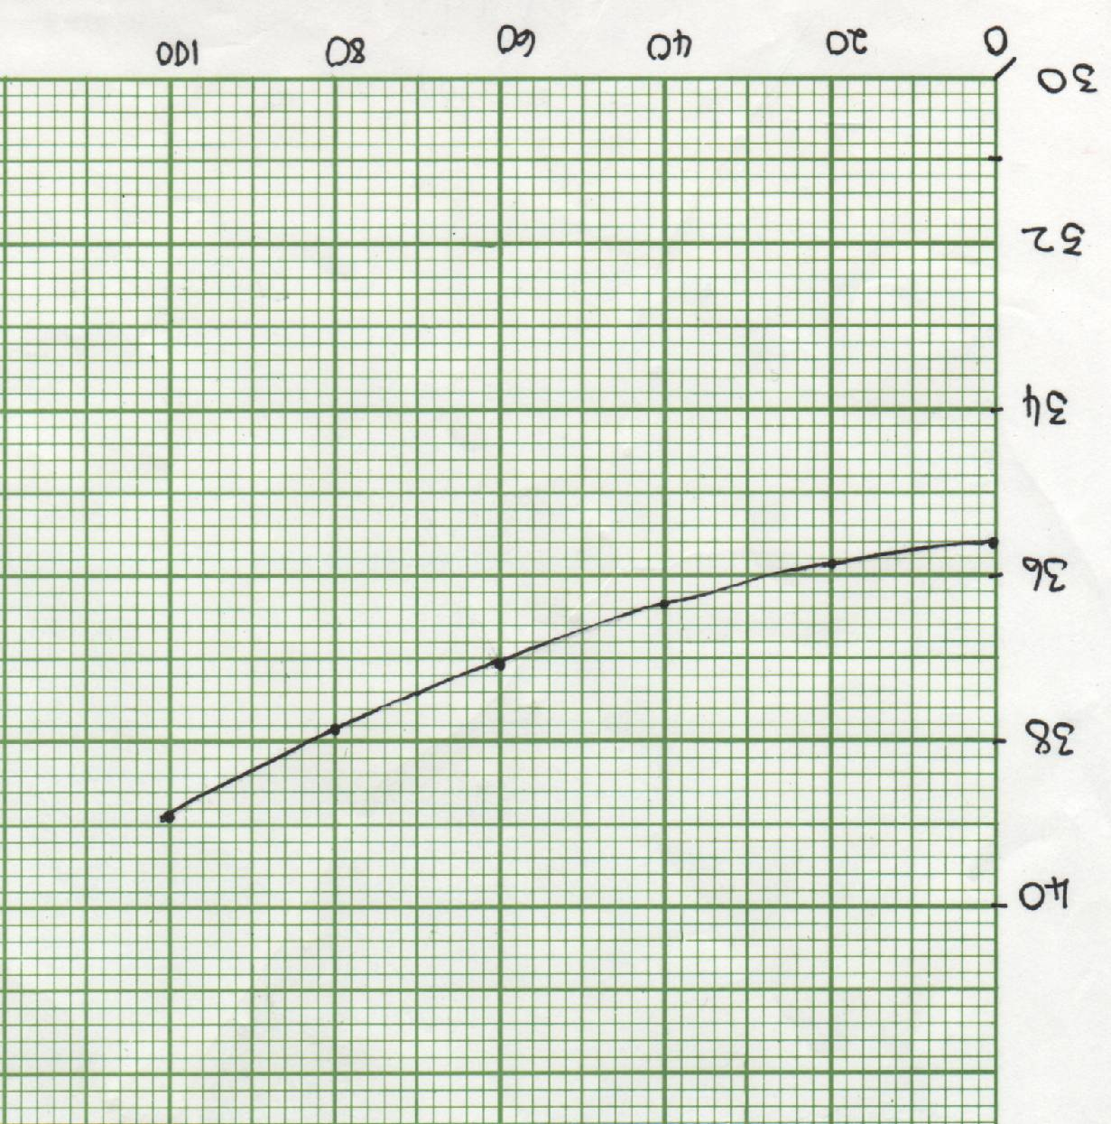
various temperatures.
0 20 40 60 80 100

Temperature (^{O}C)
40

38

36

34

32

30
Solubility (g/100ml water)

Consider the equilibrium in a saturated solution of sodium chloride:
NaCl(s) ⇄ Na⁺(aq) + Cl⁻(aq)

6.1 Is the dissolution of NaCl exothermic or endothermic? (1)

6.2 At 25^{O}C, the solubility of sodium chloride is 35,9g/100ml water.
Calculate the equilibrium constant for the system. (6)

6.3 What can be done to increase the value of Kc at for this system? Explain. (4)

6.4 At the same temperature, the equilibrium constant of a saturated solution of
Silver chloride is 1,8x10⁻¹⁰. Is silver chloride more soluble or less soluble than
Sodium chloride at 25 ^{O}C? (1)
[12]

